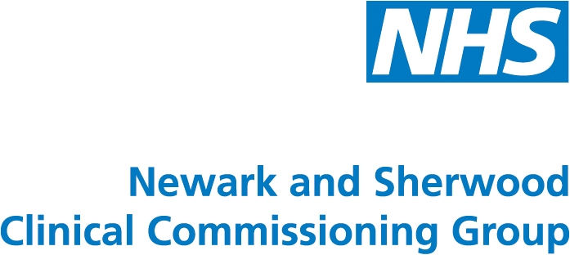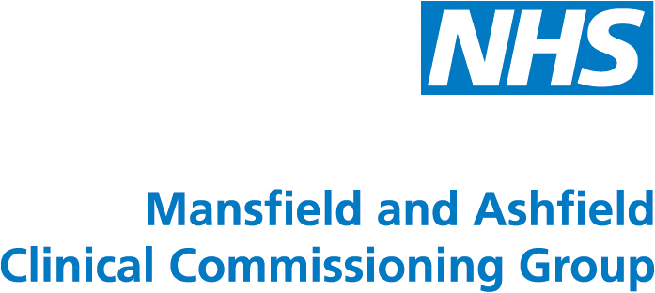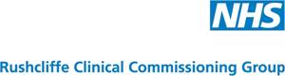

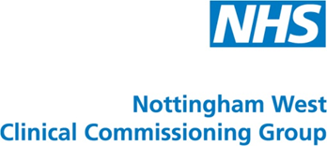

SAFEGUARDING CHILDREN

ANNUAL REPORT

1 APRIL 2012 – 31 MARCH 2013

SAFEGUARDING CHILDREN ANNUAL REPORT

2012/2013

CONTENTS

PAGE

- Introduction 3

- Safeguarding Children Governance and Accountability arrangements 3

- Monitoring of Commissioned and Contracted Services 4

- Supporting Safeguarding Standards in Primary Care 4

- Learning Lessons from Serious Incidents 5

- The Child Death Review Process 5

- Development of Nottinghamshire Multi Agency Safeguarding Hub 6

- Safeguarding Clinical Leadership and support 7

- Views of Children and Young People 7

- Priorities Identified for 2013-14 7

- Appendix 1 – Statistical data Children at risk & Children in Care 9

- Appendix 2 – Safeguarding Professional contact Map 10

- Appendix 3 - GP Safeguarding PLT Training 11

- Appendix 4 – MASH performance information 12

- Appendix 5 - Priorities Identified in Annual Report 2012-13 progress report 13

Nottinghamshire Clinical Commissioning Groups

Safeguarding Children Annual Report 2012-2013

- Introduction
  - This is the first annual safeguarding children report for Nottinghamshire Clinical Commissioning Groups (CCG’s) which gained statutory status on 1st April 2013, after operating in shadow form of NHS Nottinghamshire Primary Care Trust (PCT) following implementation of the NHS Health and social Care Act 2012. The CCG authorisation process during October and November 2012 scrutinised safeguarding arrangements within the CCG’s prior to transition, and all Nottinghamshire CCG’s were found to be satisfactory in relation to safeguarding arrangements, with no conditions for improvement imposed.
  - Nottinghamshire CCG’s commission health services for almost 150,000 children and young people across Nottinghamshire. A significant minority of these children will be living in circumstances where they are at risk of suffering significant harm from abuse and neglect or are in the care of the Local Authority (See Appendix 1). These children require co-ordinated multi agency assessments and planning to ensure appropriate protection plans keep them safe within their family or where this is not possible, to be accommodated by the Local Authority. Health workers across all services play a significant role in this process, from identifying concerns as they arise, referring children at risk to the Local Authority and contributing to multi agency assessments and plans to support children within their families or when they are accommodated into care.
  - The purpose of this report is to provide assurance that Nottinghamshire CCG’s are fulfilling their new statutory responsibilities as commissioners to promote the safety and welfare of children in all of the services they commission. It also provides an overview of work undertaken during 2012/13 and highlights specific areas requiring development during 2013/14. Achievements over the past year and priorities for the future are highlighted.
- Safeguarding Children Governance and Accountability arrangements
  - The implementation of the Health and Social Care Bill has resulted in significant organisational transformation. From the 1st April 2013 the CCG took on new statutory responsibilities and the PCT devolved its responsibilities to new NHS organisations including NHS England, Public Health England, and Commissioning Support Units.
  - Specific roles and responsibilities for CCG’s and other NHS statutory bodies around safeguarding are outlined in “Safeguarding Vulnerable People in the Reformed NHS Accountability and Assurance Framework” issued by the NHS England 31st March 2013. This document replaced previous interim guidance and is the benchmark to monitor CCG arrangements. These newly developed organisational reporting and accountability structures need to be tested and embedded throughout 2013-14 to ensure that there is clarity around roles and responsibilities.
  - The CCG governance arrangements for safeguarding children are through the Safeguarding Committee which is hosted by Newark and Sherwood CCG as part of a memorandum of understanding. The meeting is chaired by the Director of Quality and Governance for Newark and Sherwood CCG. The Committee meets bi-monthly and monitors progress on national guidance and strategic priorities. These are outlined in S10 of this report.
  - The CCG Safeguarding Committee has ratified a Safeguarding Policy in October 2012 which clearly outlines individual and organisational arrangements to comply with these responsibilities. Newark and Sherwood CCG employs a Designated Nurse and Designated Doctors are in place through Service Level Agreements with Nottinghamshire University Hospital Trust and Sherwood Forest Hospital Trust. These professionals act as clinical advisors to the CCG. Details of key roles responsibilities and accountabilities around safeguarding are outlined in Appendix 2
  - Nottinghamshire Safeguarding Children Board (NSCB) has a statutory scrutiny role, and a S11 self-assessment audit tool for commissioning and provider organisations was disseminated in April 2012. Completion of this tool has enabled the CCG not only to monitor their own performance against required standards, but also to monitor provider organisations. The CCG plan is monitored through the Safeguarding Committee.
- Monitoring of Commissioned Services
  - Nottinghamshire CCG’s commission health services from: -
- Nottingham University Hospitals NHS Trust,
- Sherwood Forest Hospitals Foundation NHS Trust
- County Health Partnerships (a division within Nottinghamshire Healthcare NHS Trust).
- Central Nottinghamshire Clinical Services (Out of hours medical services)
  - These organisations are performance managed via formal Quality Panels led by the Director of Quality and Governance (North CCG’s) and Director of Quality Governance and Patient Safety (South CCG’s) Professional clinical advice is provided by the Designated Doctors and Nurse as necessary. Safeguarding Children issues for the scrutiny panels are identified through the following means: -
- Monitoring of Service Level Agreements and Contract Schedules through Quality Scrutiny Panels.
- NSCB S11 self-assessment tool.
- Monitoring actions arising from Serious Case Reviews
- Serious Untoward Incident reporting and monitoring.
- Site visits
- Child Death Review Process
- Supporting Safeguarding Standards in Primary Care
  - Achieving and maintaining professional competencies in safeguarding is the responsibility of all clinicians as part of their General Medical Council/Nursing and Midwifery Council professional registration requirements. They GMC has provided guidance to all GP’s outlining their individual responsibilities regarding this. As GP contract holders, monitoring of compliance with these professional standards is a function of the newly established Local Area Team (LAT) of the NHS England through the GP revalidation process.
  - Accountabilities for CCGs are described in the Safeguarding Vulnerable People in the Reformed NHS as having a “duty to support improvements in the quality of primary medical care”
  - Throughout 2012-13 the Nottinghamshire CCG’s have continued to provide support for local GP’s and primary care clinicians in the following ways: -
- On-going programmes of Protected Learning Training events which have prioritised safeguarding training supported by the Designated Nurse and Named and Designated Doctors. (See Appendix 3). Evaluations of the event from participants demonstrated a satisfaction score of 4.3 of total 5
- A programme of training for GP safeguarding leads to equip them with the skills and confidence to undertake their role as practice lead for safeguarding. (See appendix 3)
- PLT briefings to update GP practice staff on the MASH and the role of primary care.
- A Safeguarding Children GP website for Nottinghamshire has been launched which is a source of information and key local contacts
- A briefing to all GP’s detailing training requirements and how to access training has been circulated by the clinical leads.
- The Designated professionals have developed and secured funding for a safeguarding children app which will be rolled out to clinicians in Summer 2013
- Learning Lessons from Serious Incidents
  - The Director of Quality and Governance (North CCG’s) and Quality and Patient Safety (South CCG’s) are members of Nottinghamshire Safeguarding Children Board. The Designated Professionals are professional advisors to the Board and represent the CCG’s on the NSCB Standing Serious Case Sub-Group (SSCSG) and the Performance and Quality Sub-Group. (P&QSG) and the Executive committee. The Designated Nurse is Chair of the Nottinghamshire Child Death Overview Panel (CDOP).
  - The SSCSG oversees and quality monitors serious case reviews and individual organisation Independent Management Reviews (IMR’s) and associated action plans. The P&QSG commissions joint agency audits and scrutinises and evaluates impact evidence of key recommendations from serious case reviews. Through membership of the Board and its sub-committees the CCG has oversight of provider organisations progress in implementing and effecting change as a result of the serious case review process. The CCG Safeguarding Committee also monitors progress of SCR action plans as a standing agenda item.
DN11
  - During 2012-13 the findings from a serious case review which was commissioned in 2011 were published. (DN11) This case related to the serious sexual abuse of several boys in the care of the Local Authority over a number of years by a male foster carer. Despite significant involvement with a range of health services over a number of years, recommendations for health agencies were few in number and the review highlighted many areas of good practice and developments in safeguarding over recent years. CCG Boards received a paper outlining key lessons learned from this review during April/May 2012 and the lessons learned are now incorporated into safeguarding training programmes.
EN12
  - EN12 was a pre-term baby who after several weeks on the Neonatal Unit was discharged home. He subsequently sustained serious head injuries and will have permanent and substantive disabilities as a result. Key themes emerging from this review have been circulated to GP’s and implementation of organisational action plans is being monitored by the NSCB. A joint agency pathway for the management of bruises in non-mobile babies has been developed and is undergoing ratification by the NSCB. The final overview report should be published during 2013 pending completion of police investigations.
Child Sexual Exploitation (CSE)
  - Recent cases of CSE including operation Retriever in Derbyshire are revealing the extent of child sexual exploitation across the country. A House of Commons Select Committee reviewed several serious cases including those in Oxford and Rochdale has recently made recommendations that the Local Safeguarding Boards take responsibility for leading strategic plans to tackle the issue, including the development of Multi Agency Safeguarding Hubs.
  - Nottinghamshire LSCB in collaboration with the City Safeguarding Children Board has been proactive in developing a cross authority Child Sexual Abuse Strategy which is overseen by the LSCB. Designated Professionals from the CCG’s are represented on this group as professional advisors. The Nottinghamshire MASH is also contributing to improved multi agency collaboration around this issue. 2013-14 year will see the implementation of the strategy which should greatly improve agency responses to this complex issue.
Domestic Abuse
  - The scale and prevalence of domestic abuse has been highlighted by recent domestic homicides across the County as well as analysis of children subject to child protection plans, 60% of whom are living in households where domestic abuse is a factor.
  - Reports and action plans from domestic homicide reviews have been developed and monitored by members of the Quality and Governance Directorate of Newark and Sherwood CCG as members of Community Safety Partnership panel meetings. Resulting action plans and progress reports are monitored by the Safeguarding Committee.
  - Provider services are monitored around their plans to implement the domestic violence agenda through the NSCB S11 review process. It has been noticeable over the last year the increased profile that providers are placing on training, awareness raising and responding to domestic abuse within individual organisations.
  - During 2012-13 the CCG’s received reports from Public Health which outlined the scale and prevalence of domestic abuse across the county and identified opportunities to address the concerns. These papers were well received and the CCG’s continue to support work in this area through the Health and Wellbeing Board. The Nurse Director of Quality and Governance for Newark and Sherwood CCG represents County CCG’s on the Safer Nottinghamshire Board Domestic Violence Strategy Group which is steering local multi agency responses to the issue.
- The Child Death Review Process
  - CCG’s have a statutory duty to secure the expertise of consultant paediatricians whose responsibilities are to organise and provide advice on the commissioning of paediatric services which undertake enquiries into unexpected deaths in childhood, and provide medical investigative services. These services are commissioned from NUH and SFH. (See Appendix 2)
  - The LSCB is responsible for ensuring that a review of each death of a child normally resident in the LSCB’s area is undertaken by a Child Death Overview Panel (CDOP). The CCG Designated Nurse is Chair of the Nottinghamshire CDOP. The table below outlines numbers of child deaths notified within the reporting period.
 | 07.03.12-06.06.12 | 07.06.12- 17.09.12 | 18.09.12- 03.12.12 | 04.12.12- 05.03.13 | Total
No of Notifications | 15 | 9 | 13 | 17 | 54
Expected deaths | 8 | 4 | 7 | 10 | 29
Unexpected deaths | 7 | 5 | 6 | 7 | 25

  - When a comparison was made with the number of child deaths in the previous year (2011/12) it was noted that there were similarities in the numbers of expected deaths. There has however been a significant 66% rise in unexpected deaths which have increased from 15 to 25 this year. Further analysis is underway to explore reasons for this and will be reported to the NSCB executive in 2013.
  - Recommendations and issues identified from the CDOP process have included: -
        - Advice to parents about dangers of plastic mattress covers
        - Advice to parents around safe bathing arrangements to prevent risk of drowning
        - Road safety issues for teenagers
        - Dangers and consequences of alcohol in pregnancy
        - Advice to parents around safe sleeping arrangements
        - Diagnosis and management of sepsis in young people
  - Actions to address the above have been progressed through public health information programmes, awareness raising across provider organisations and front line clinicians and the LSCB leading the development and funding of a road safety awareness film project aimed at 14 to 17 year olds in association with the County Youth Arts and road safety partnerships. The LSCB will continue to monitor the progress of this during 2013.
- Development of Nottinghamshire Multi Agency Safeguarding Hub
  - Newark and Sherwood CCG on behalf of the Nottinghamshire CCG Cluster has worked with the Local Authority and Nottinghamshire Police to develop a Multi-Agency Safeguarding Hub. (MASH) The MASH, which went live in November 2012, is a central resource for the whole of Nottinghamshire receiving all new adult and child safeguarding enquiries. The CCG has secured funding to provide a team of 5 health practitioners within the MASH (2 admin and 3 clinicians) who contribute to the information sharing and assessment processes.
  - The MASH acts as the first point of contact for all new child or adult safeguarding concerns in Nottinghamshire which meet current thresholds. Once a concern is reported, the MASH team assess whether it meets the threshold for Adult or Children’s Social Care involvement. Those that do are passed for information sharing from a range of different sources, allowing better informed decisions to be made. This results in improved sharing of significant information with health practitioners. As a result, agencies are able to act quickly, in a more co-ordinated and consistent way, promoting the safety of vulnerable children and adults.
  - The Director of Quality and Governance Newark and Sherwood CCG represents the Notts CCG’s on the MASH Strategic Steering group. The Designated Nurse sits on the MASH Operational Group and Chairs a Notts MASH health partnership group which involves key stakeholders from all health providers to ensure a partnership approach across the health community. A summary of key performance data relating to the MASH is shown in Appendix 4
  - Progress continues to improve the systems and processes within the MASH to optimise the benefits for clinicians and vulnerable children and adults. Additional funding has been secured to complement the existing health team within the MASH and it is expected that the health team will continue to develop and improve communication with health staff around areas of risk for patients and clients, multi-agency discussions and decisions around managing risk.
- Safeguarding Clinical Leadership and support
  - There is an established Nottinghamshire and Nottingham City Safeguarding Children Health Partnership which is jointly chaired by the Designated Nurses for Nottinghamshire and Nottingham City. This group includes representation of safeguarding leads from all health provider organisations across the City and County and aims to develop expertise, professional support and shared learning around safeguarding. This group links to the regional safeguarding forum which, following the dissolution of the Strategic Health Authority will be led by the Local Area Teams of the NHS England. As representative of the CCG’s, the Designated Professionals will continue to lead and influence the work of these safeguarding professional forums.
- Views of Children and Young People
  - Safeguarding practice around vulnerable children is complex, frequently under review and we must ensure that it works effectively. The final report of the Mid Staffordshire NHS Foundation Trust Public Inquiry recommends that healthcare should be patient centred to ensure the best interests of vulnerable people including children. Organisations need to promote a culture where voices of vulnerable people are heard and staff feel able to raise concerns and whistle-blow without fear of recrimination. High profile national cases such as the Savile enquiry as well as local cases have highlighted that children and young people are often not listened to or taken seriously when the voice concerns. All Nottinghamshire CCG’s make efforts to ensure that as part of their patient centred approach, the voices of children and frontline staff are taken into account to inform service development and delivery across all commissioned services.
  - A multi agency audit into the “voice of the child” led by the NSCB was undertaken in 2013 by all major health providers which gave reassurance that in the vast majority of cases studied, where children and young people access healthcare, they were given opportunities to be seen alone where appropriate, and their views and the views of their parents and carers were taken into account. The full findings of this audit will be presented to the NSCB in summer 2013.
- Progress and priorities Identified for 2013-14
  - Progress against the priorities identified last year in the NHS Nottinghamshire PCT Annual Safeguarding Children Report 2011-12 are detailed in Appendix 5. It can be seen that despite a period of change and re-organisation, significant progress was achieved.
  - Priorities identified for the year 2013-14 will be monitored through the CCG Safeguarding Committee and are based on the standards outlined in “Safeguarding Vulnerable People in the Reformed NHS Accountability and Assurance Framework” (March 2013) namely: -
- Maintain CCG membership of the NSCB and fully engage with the Local Authority to fulfil safeguarding responsibilities including reviewing and reporting on the progress of Nottinghamshire MASH to identify impact and quality outcomes.
- Maintain robust processes to learn lessons from cases where children die or are seriously harmed and abuse or neglect is suspected. This will include contributing fully to Serious Case Reviews (SCRs) which are commissioned by NSCB.
- Ensure representation and effective contribution to the newly established Joint Children’s England to “influence the commissioning of high quality integrated pathways of care for all children and young people from maternity and right through to adult services”.
- Gain assurance from commissioned services that they have effective safeguarding arrangements in place and that the views of children and young people and frontline staff inform service development.
- Demonstrate that designated clinical experts are embedded in the decision making of the organisation, with the authority to work within local health economies to influence local thinking and practice.
- Work with primary care commissioners and local CCG clinical leaders to develop effective arrangements for the employment and development of named GPs (and other primary care expertise) within the local area.
- Work with the Local Area Team of the NHS England to contribute to the continued development of Safeguarding Clinical Forums
- Ensure CCG staff induction programmes incorporate safeguarding requirements and that CCG staff attendance is evidenced and reported to the Safeguarding committee.
- Continue to support and improve the quality of primary medical care by continuing to offer PLT events and GP safeguarding lead training to all CCG’s across the County

APPENDIX 1

Number of Children Subject to a Child Protection Plan and in Care of the Local Authority

Fig 1

Figure 1 demonstrates the year on year increase in Children in Care (CIC) and children subject to a Child Protection Plan (CPP) from 2008-13. This represents a 47% increase in LAC and a 50% increase in CPP. This is a result in a combination of factors including the media outcry from the Baby Peter case in 2009, an improvement plan for Nottinghamshire Children’s Social Care in 2010 and increased political pressure to accommodate children living in abusive and neglectful circumstances.

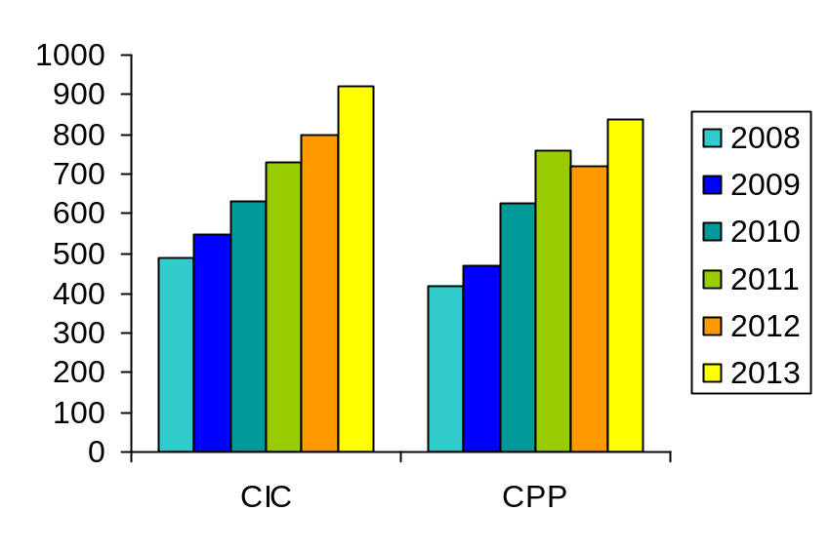

Fig 2 Demonstrates numbers of Children in Care After compared with statistical neighbouring authorities. It can be seen that Nottinghamshire remained below the national average in 2011.

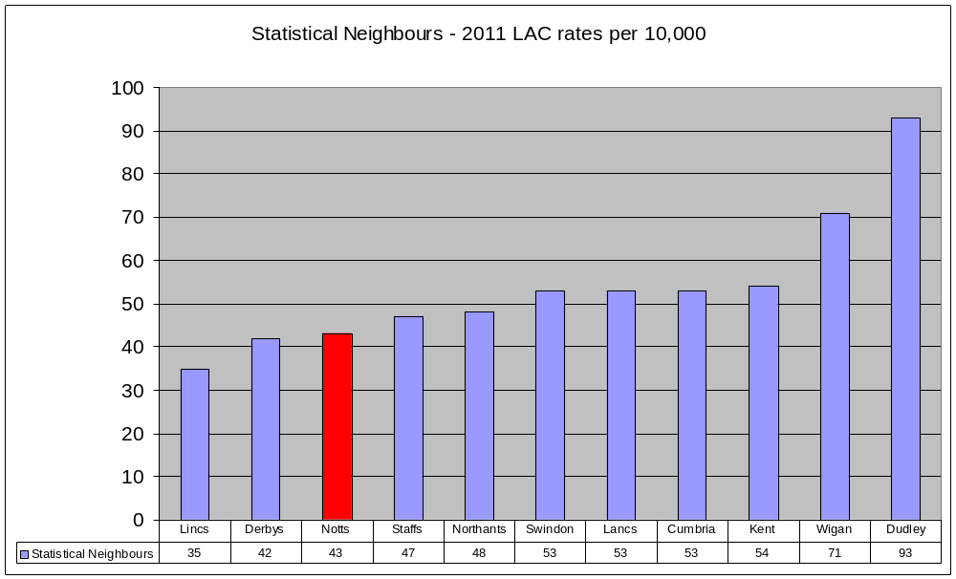

Fig 3 Figures below indicate numbers of children subject to a Child Protection Plan as identified by LA rather than CCG boundaries. CCG specific data is unavailable at this time.

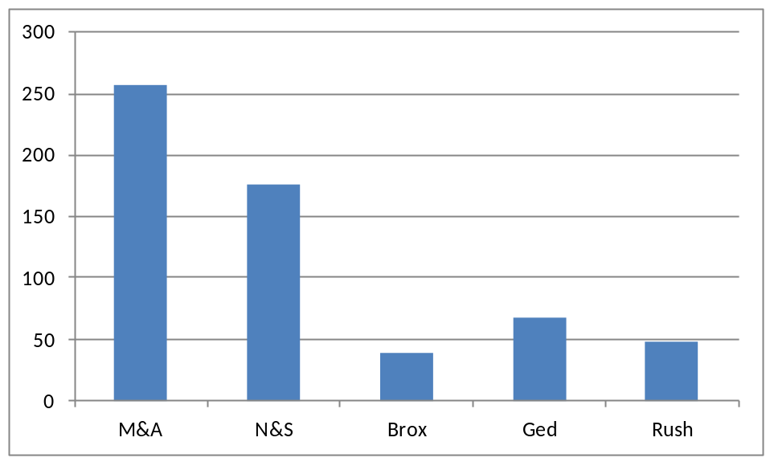

Number of Children in Care of the Local Authority 2011-12

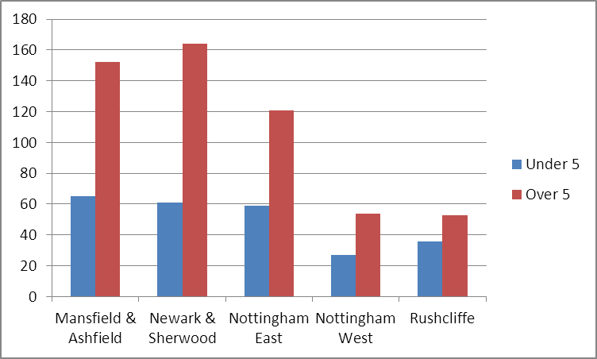

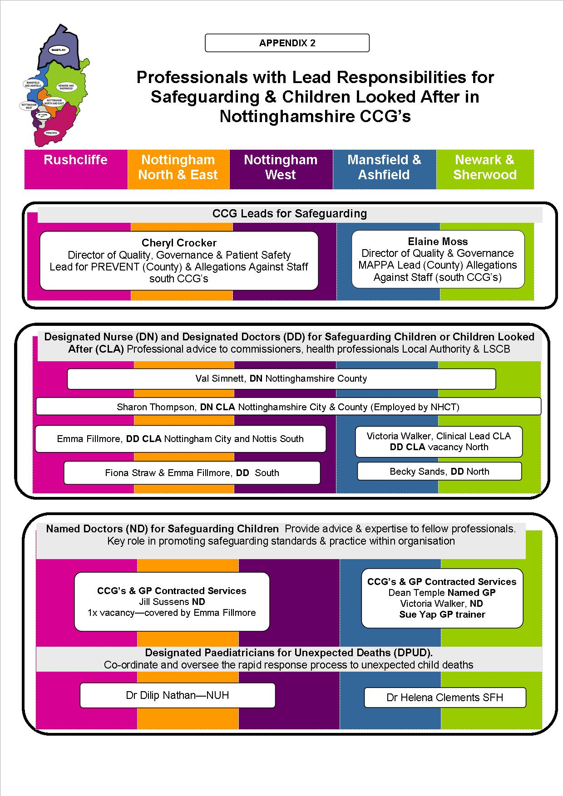

Appendix 3

CCG Support for GP Practices in Safeguarding Children Training

The table below shows numbers of GP practice staff in receipt of safeguarding training during the reporting period. A total of 422 staff attended training from the CCG’s.

Safeguarding Children Protected Learning Events Delivered

1st April 2012 - 31st March 2013

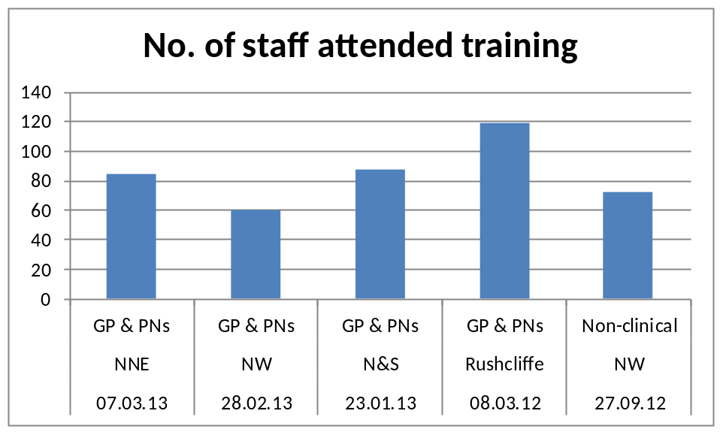

GP Safeguarding Lead Events

A programme of events is underway for GP practice safeguarding leads who have a responsibility to promote safeguarding standards within individual GP practices. The training is aimed at supporting and developing them in their safeguarding leadership role. The rollout began in the north of the County and will continue across the south CCG’s throughout 2013. The table below shows numbers attending the sessions during the reporting period.

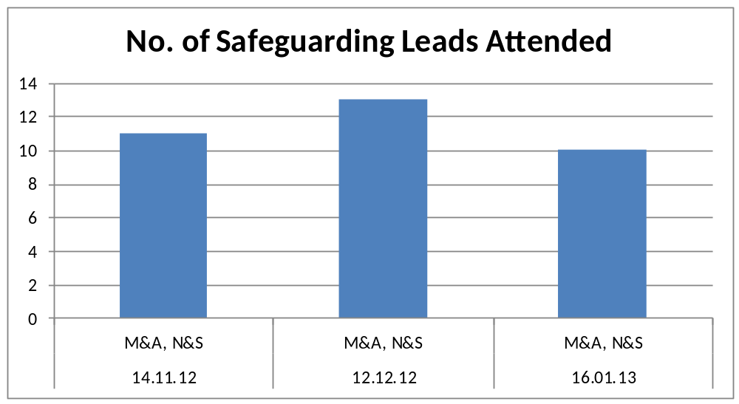

Appendix 4

MASH Performance Information

Number of enquiries to MASH Health Team Jan-March 2012

The MASH health team receive requests for information which require communication and liaison with a range of health professionals ranging from GP’s, Health Visitors, Midwives, School Nurses and adult Specialist Mental Health and Substance Misuse workers as well as a range of allied health professionals and paediatric specialist services.

Fig 1 shows the number of enquiries and range of service involvement resulted in difficulties getting the full health information package produced within required timescales. This resulted in 2 levels of response being achieved: -

Level 1

Cases are returned with basic information and contact details of health services involved (e.g. GP paediatrician)

Level 2

Cases are returned with more comprehensive information relating to when the child was last seen, details of significant issues identified and health workers views on the vulnerability and impact of health assessments.

Figure 1

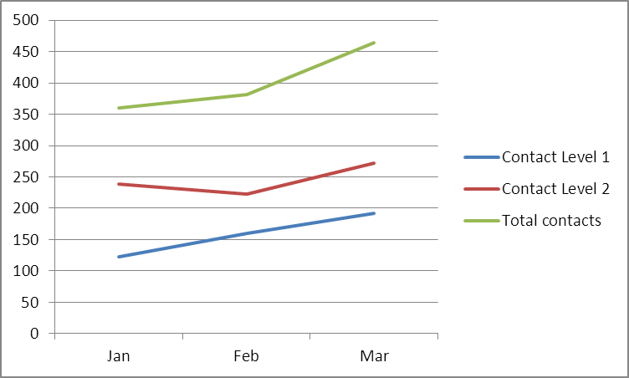

An additional post for a specialist health practitioner has been appointed and will commence June 2013 as well as developments to improve access to health systems.

The aim is to give level 2 responses to 95% of enquiries within timescales. This will be monitored throughout 2013.

Appendix 5 NHS Nottinghamshire County tPCT Safeguarding Children Strategic Action Plan 2011-12 Progress Report

 | Priority | Progress March 2013 | Status | Evidence
1 | Continue to monitor and review safeguarding reporting and accountability arrangements across the Nottinghamshire CCG’s in response to National and local developments, ensuring robust links with the NSCB are maintained. | Reporting and accountability arrangements clearly outlined in the CCG memorandum of understanding and Safeguarding Policy. | Complete | CCG Safeguarding Policy and Memorandum of Understanding
2 | Embed a pathway for CCG’s to share lessons learned following Serious Case Reviews, Domestic homicide Reviews and serious incidents to improve learning to safeguard children | Pathway developed and ratified by Safeguarding Committee | Complete | Serious Case review Pathway
3 | Progress the appointment and development of GP Independent Management Review Authors to provide a pool of expertise for Serious Case Reviews and Domestic Homicide Review processes | GP IMR authors recruited and completed EN12 IMR. Responsibilities of these roles will be within the LAT from 1st April 2013 | Complete | GP IMR EN12
4 | Further develop links between Designated Professionals and CCG safeguarding leads across Nottinghamshire CCG’s | Designated Nurse is managed by Safeguarding lead North county and meets regularly with Safeguarding leads south county. Designated Doctors attend CCG Safeguarding Committee | Complete | Schedule of meetings
5 | Ensure CCG employees achieve minimum mandatory standards of safeguarding training | Local face to face seminars were provided in each CCG locality in 2012. A flyer went to all employees reminding of e-learning opportunities. Need to consolidate staff induction programmes and ensure evidence of compliance is available. | Carried over to 2013-14 | Schedule of training delivered and e-learning flyer.  All CCG’s are reviewing their mandatory training and induction programmes
6 | As part of the GP training strategy develop a programme of training and support for GP practice safeguarding leads | The designated and Named professionals have delivered training to GP practice Safeguarding Leads. | Complete | GP feedback and evaluations
7 | Through rollout of the GP safeguarding toolkit, ensure GP’s have easy access to accurate contemporaneous information to inform their practice | A Childnottsafe GP website has been developed by the Designated professionals, allowing all GPs easy access to local and national information relating to safeguarding children | complete | www.childnottsafe.org.uk
8 | In partnership with the Local Authority work to improve accurate reporting of GP’s contribution to child protection processes | An audit into GP attendance at Child Protection Conferences was undertaken and shared with Nottinghamshire Safeguarding Children Board manager and Local Authority representatives. This issue continues to be monitored through the NSCB performance data. | Complete | Document presented to Safeguarding committee April 2013
9 | Inform, influence and contribute to the development of the Multi Agency Safeguarding Hub | Nottinghamshire MASH went live Nov 2012 and continues to develop with health as a lead partner | Complete

Section 11 of the Children Act 2004 and Working Together to Safeguard Children HM Government 2013
NHS England “Safeguarding Vulnerable People in the Reformed NHS Accountability and Assurance Framework” April 2013
www.childnottsafe.org.uk
House of Commons home Affairs Committee Child Sexual Exploitation and the Response to Localised Grooming 2013
NHS England Commissioning Factsheet for CCGs (July 2012) www.commissioningboard.nhs.uk
NHS England “Safeguarding Vulnerable People in the Reformed NHS Accountability and Assurance Framework” April 2013

